AWS Day 2 Task
Task 1: Create an IAM User and Attach Policies
How to create user in AWS IAM
step 1: IAM User creation
· Login to AWS console , open root user and Search IAM
· click user and create user
· give user name >>> user1 >> click the check bot to access aws console
· create own password to login >> uncheck box user must create new password at next sign in , this option is user in organization level to change the common password provide by admin.
· click Next.
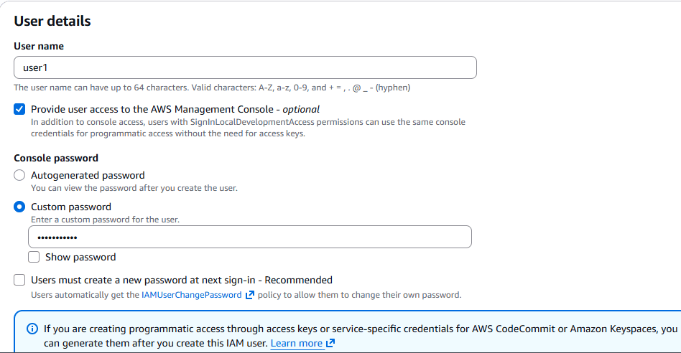
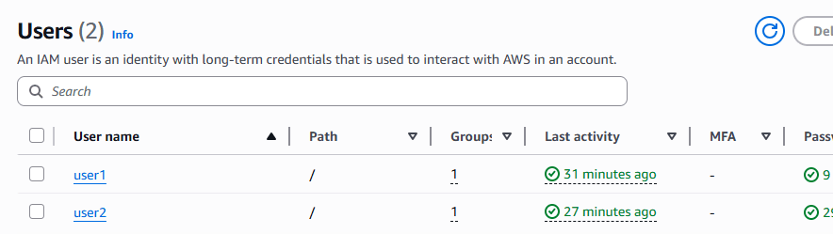
Step 2 : Set policy
Assign policy to user >> With out policy user can't access any console , with policy user is dummy.
in permission tab we have the option to add policy >> click attach policy directly
here we can add the permission what aws provided as per practice level or we have option to create new own policy >>> in organization level they will create multiple own policy.
as of now we can give aws provided permission as Admin access
we have another option in permission >> Set permissions boundary - optional
here we can set permission limit (eg: if you set read only access to S3 bucket for the user in permission Boundry) though you assign admin access in policy it won't work , user can access entire console, only he/she can able to access S3 bucked only read access is allowed.
Click Next and confirm account creation.

Task 2: Create an IAM Group and Attach Policies
Group is used to provide access to multiple user in single shot based on their role, once user can add in many groups.
How to create group in AWS IAM
step 1: IAM Group creation
· Login to AWS console , open root user and Search IAM
· click user group and create group
· give user group name >>> DevTeam>> add users into the group and attach policy to the group, like reach access for s3, EC2 full access.
· click Next.
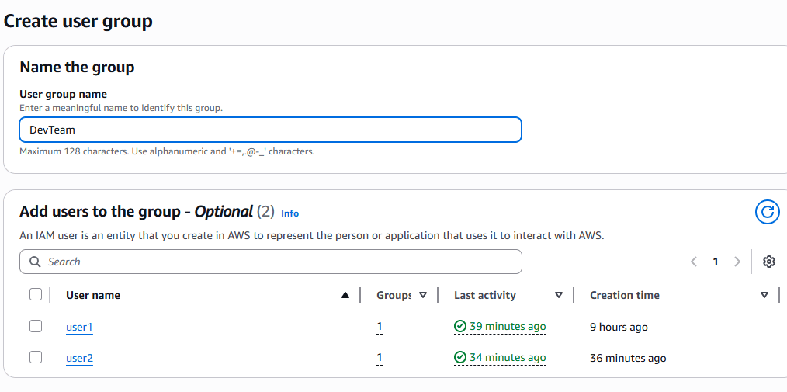
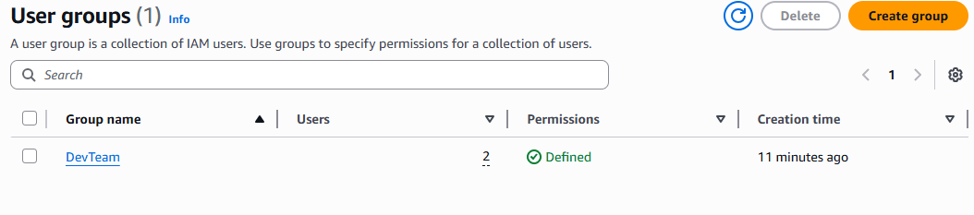

Task 3: Create a Custom IAM Policy
Types of policy's
step 1: IAM Customer Policy's
· Login to AWS console , open root user and Search IAM
· click policy and create policy as per our condition
· click Next.
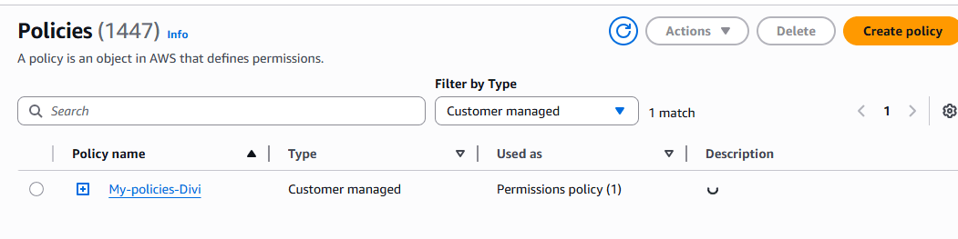

↓ ↓ ↓
Customer Inline - ‌We can create our own customer inline to specific user and assign what ever we needed to the user.
If you delete user, the inline policy will delete automatically, because it assign for that user alone
AWS Manage the policy, we can't able to edit the policy
Customer Manages - ‌We can create our own customer policy based on our condition like list,write and read. That policy can be assigned to multiple users and groups.
Here if you delete the user only user will be deleted,no the policy

step 2: IAM Customer Inline Policy's
· Login to AWS console , open root user and Search IAM
· click user and open specific user and add permission in that click inline policy
and create as per our needs
· click Next
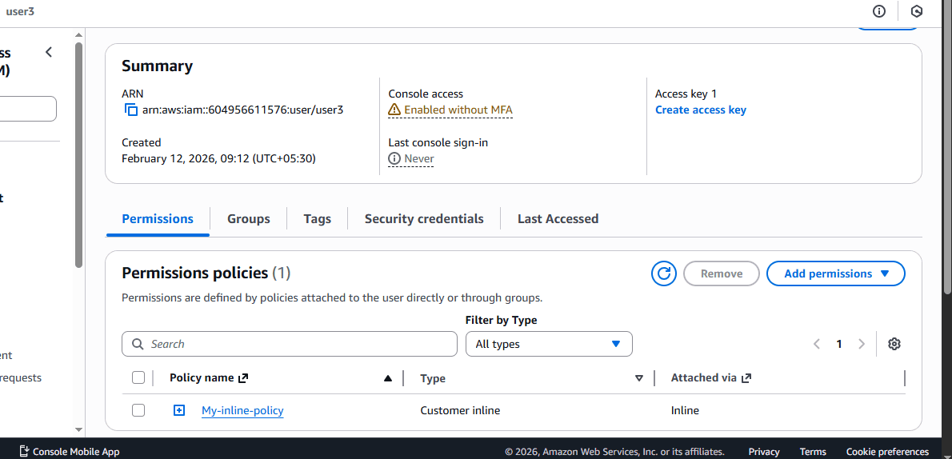
Task 4: Create an IAM Role and Attach Policies
what is role : Role is used to connect server to server from AWS service (eg: Ec2 >> S3)
Step: 1 IAM Console
· Login to AWS console , open roles >> create roles
· click aws service >> service to use >> Ec2 >> text >> set policy for s3 full access
. we need to launch ec2 instance and click action security >> modify IAM role >> add our created role and update
here we connect EC2 from EC2 we connect s2 bucket > server to server in CLI with out any password or user id
By using cli we can access server to server without credential.
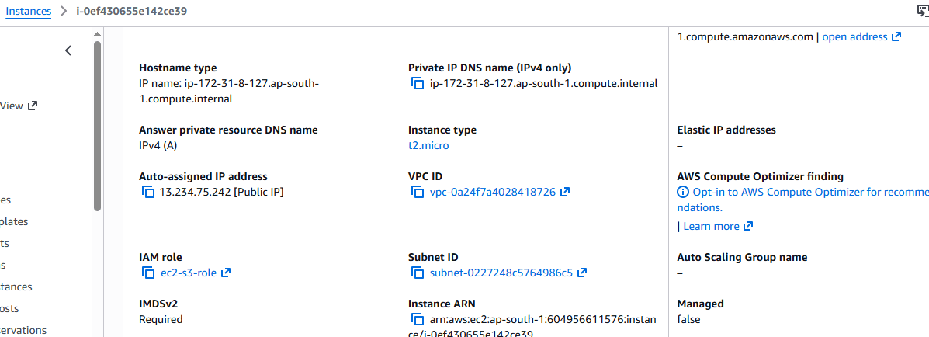
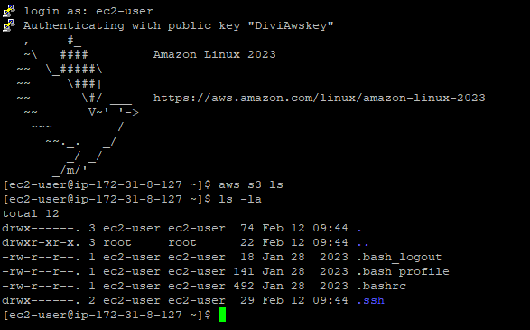
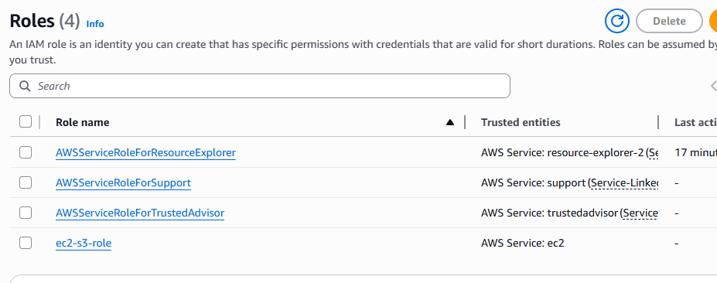
What is CLI >> we can access AWS console in another way by using CLI
we have to install CLI in our local machine and open cmd and test it was installed in our machine
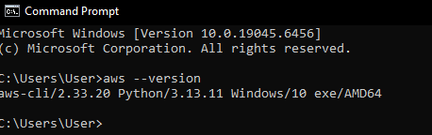
we have to got any user and create access key in cli that will give you Access key and private key. with that help we can access CLI in CMD
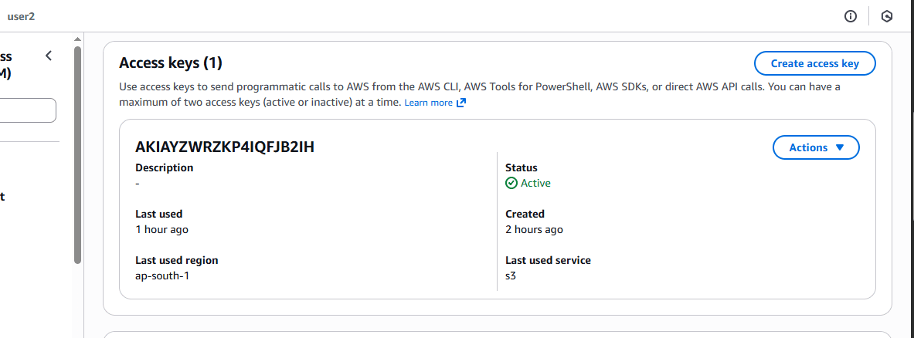
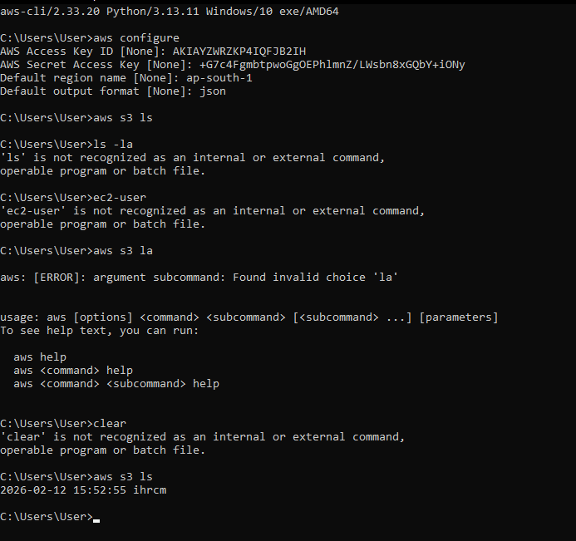

Day 3 and 4: Class is about what is EC2
EC2- Elastic Computing Cloud
Why we need EC2 in cloud = To get multiple VM (Virtual Machine), that can be customised as per your company requirement or personal requirement. It can increase the storage, RAM, CPU , whenever we required as per the flow , if you want reduce the storage, CPU, RAM its possible in EC2. As per the process you can pay per month. Its called Pay as you Go. If you don’t want VM you can terminate that particular VM , it won’t charge by AWS. It is chargeable only for running machines.
Example : if you are running a company , you have to but multiple server, storage like , RAM, CPU, Graphic card.
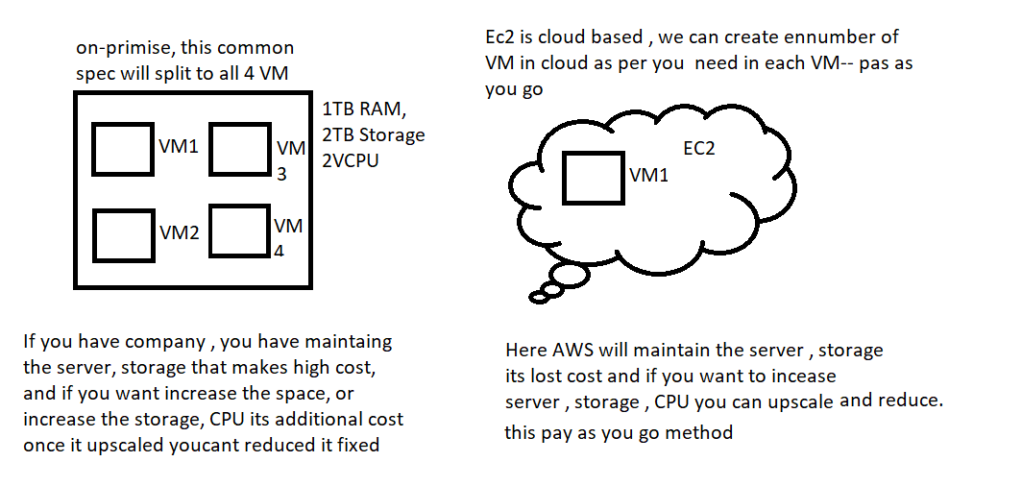
Task 1>> How create Ec2 Instance in AWS/ Launch an EC2 Instance
- Go to AWS console >> Search EC2 >>> right side you will have launch instance>> click
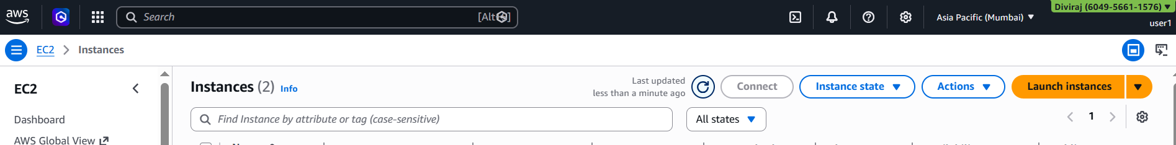

- Fill the information required as your need
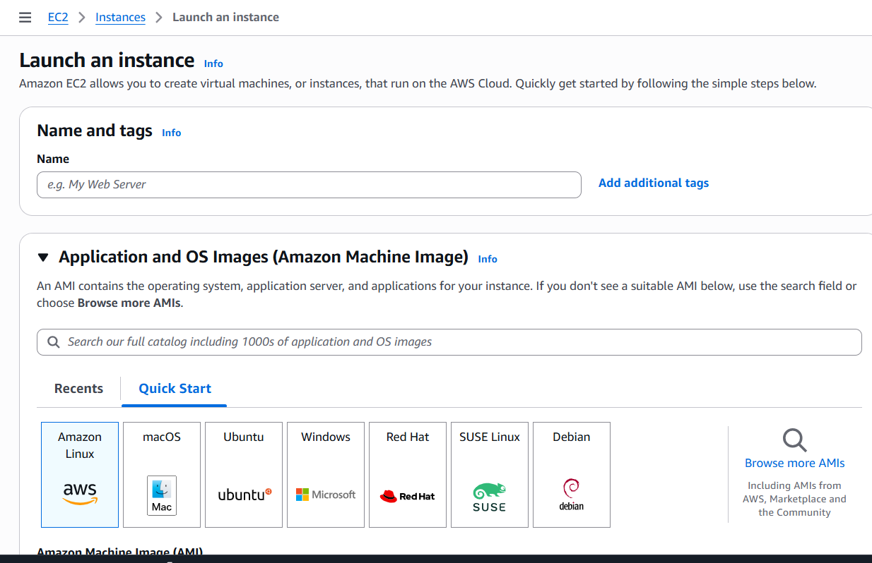
- Name: As per company policy
- AMI (Amazon Machine Image) (OS) >> as per requirement
- Instance Type >> we have multiple instance type
- General Purpose: CPU: Memory >>1:1. If CPU is increased then Memory size also increase.
- Compute Optimization: 2:1 >> only processer will increase for the performance, storage remains same. This is benefit who works in Application level in VM and I will be high performance web service.
- Memory Optimization: 1:2 >> here memory will priority is high > CPU is low, RAM is high.
- Storage Optimization: we have Database in VM, we need high performance in Input and output file transfer or data transfer, so we go with storage for performance.
- Accelerated Computing: It’s like Graphic card(GPU) if you need we can use its mostly used for Gamers and Animation.
- HCP Optimization: High Performance computing.

So choose as per the requirement in Instance type
- Key pare >> this is for security purpose, you can access the VM through internet in secure gate way >>> create key pair >> get Private key and store in local.

- Network setting >> is to access you windows in (Remote Desktop) ,HTTP and HTTPS is to access in browser level in VM.

- Configure Storage >> as per the business need.

- Click launch.

For connecting you required
User name >> Password >> Public IP Address
All this you can take from your instance.

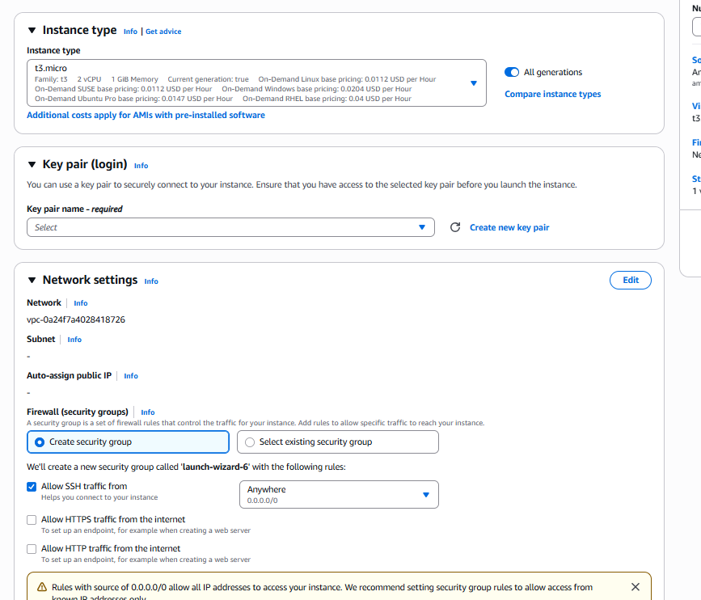
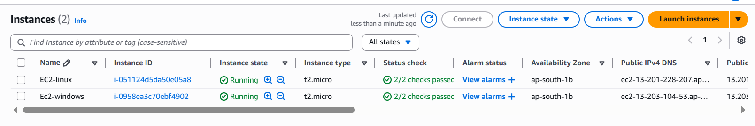
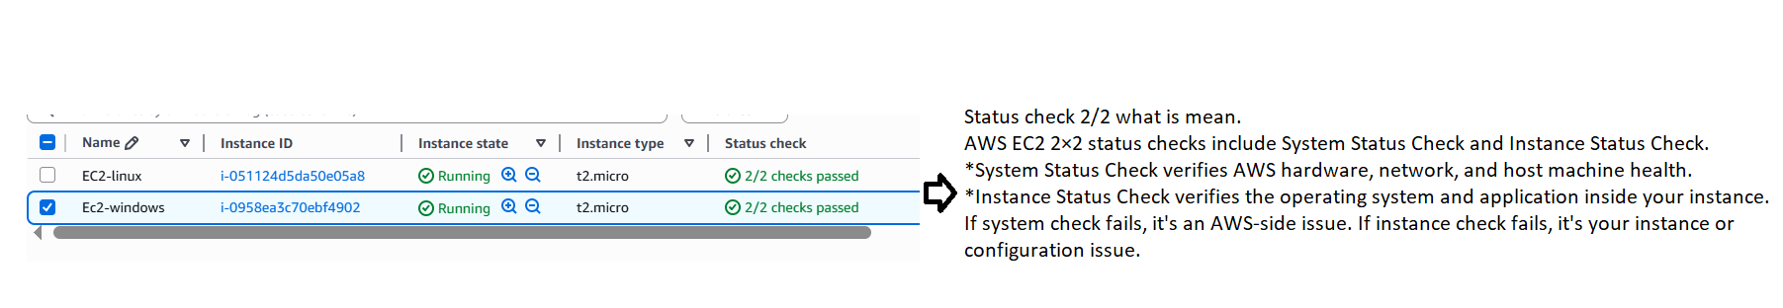

For connecting to windows and Linux you required
User name >> Password >> Public IP Address
All this you can take from your instance
For connecting windows we can use local Remote Desktop
click connect and get Public IP and click RDP to get password by uploading the private key
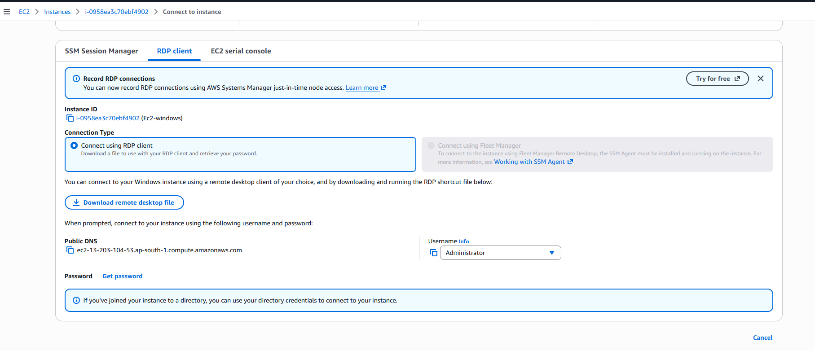
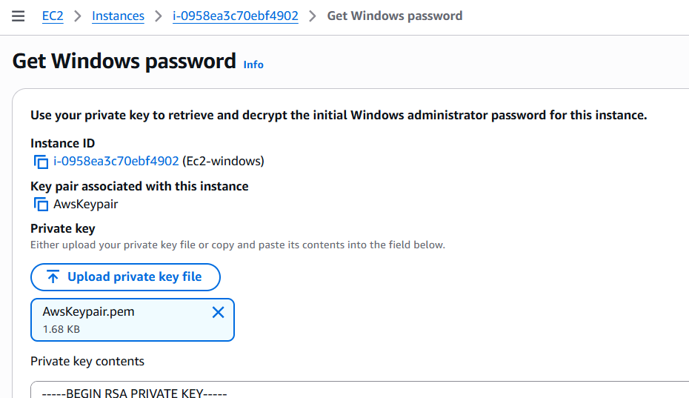
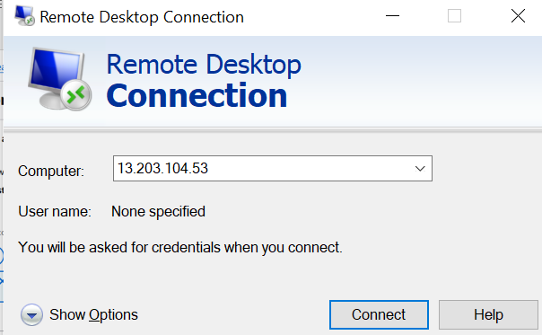
For connecting, we have to download Putty and can access the unix machine.
Got to puttygen and convert the private key and open putty and access the unix machine
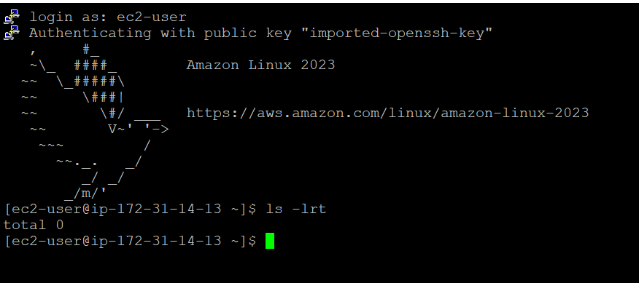

Task :2 > Create a Snapshot of the Instance’s Root Volume
- Snapshot is nothing but to take back up of the application installed in Root volume (in VM) snapshot is take backup from data level, OS level, not instance level, if instance is deleted snapshot of instance also will be deleted.
- Snapshot is read only copy of EBS volume, it will store in S3 bucket in backend.
How to create Snapshot
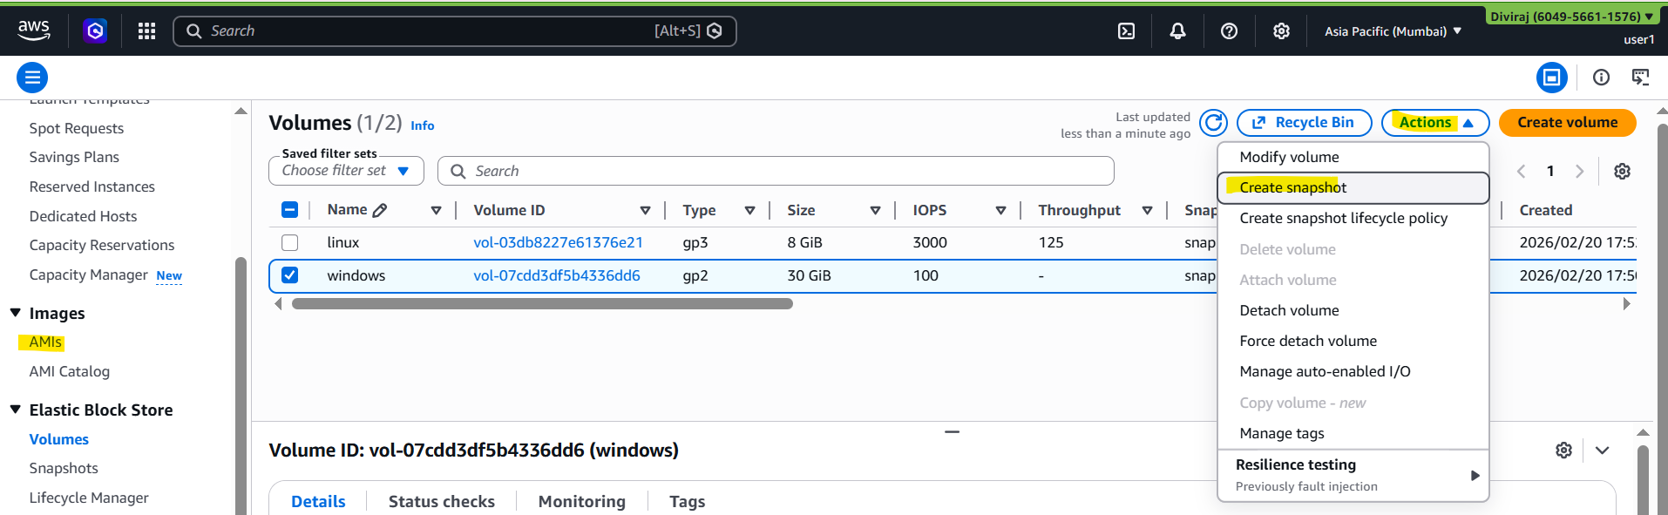
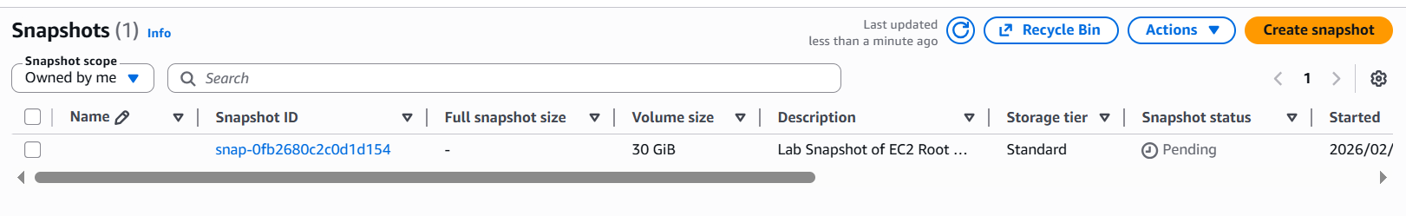
By having this snapshot, we can create customise AMI .
Task 3: Create a New Volume from the Snapshot
Volume is to increase the disk in VM and share the data from once VM to another VM and data is stored in VM leave until we take data volume snapshot.
How to Create Volume for separate disk
- Go to Volume >> click the windows check box >>Action >> create volume >> add the storage >> AZ region as per the instance >> create
- Click check box of new volume snap >> Action >> create snapshot >>>> AZ region as per the instance >> create >> this will take the data level back whatever available in new Disk created in volume.
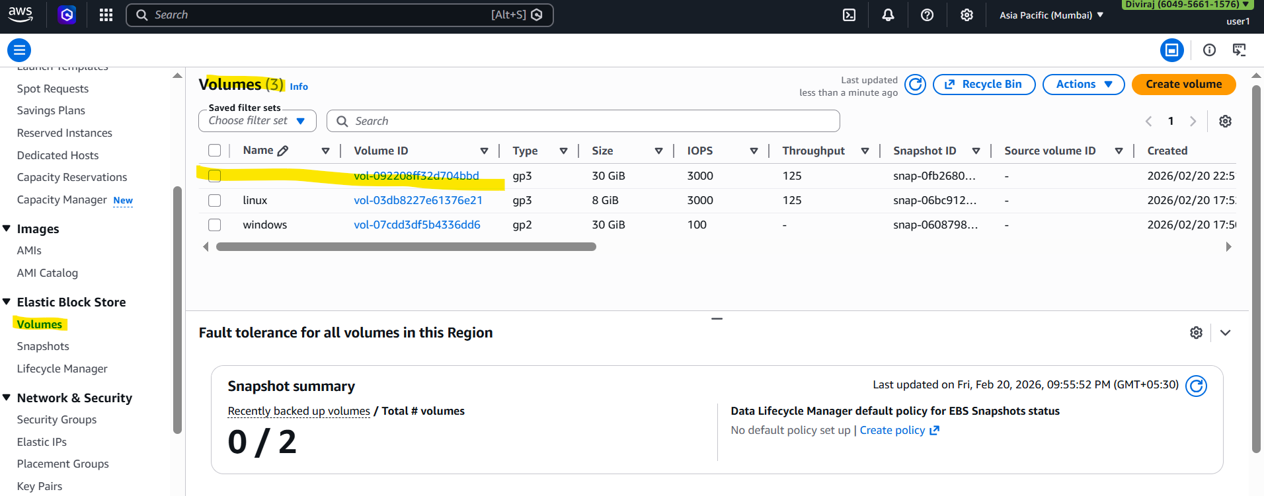
How to create Volume snapshot
If data is deleted in VM disk and if volume snapshot is taken it will store in S3 bucket at back end, with snapshot we can able to create new data volume.
- Go to snapshot >> click the windows check box >>Action >> create volume from snapshot >> details >> AZ region as per the instance >> create
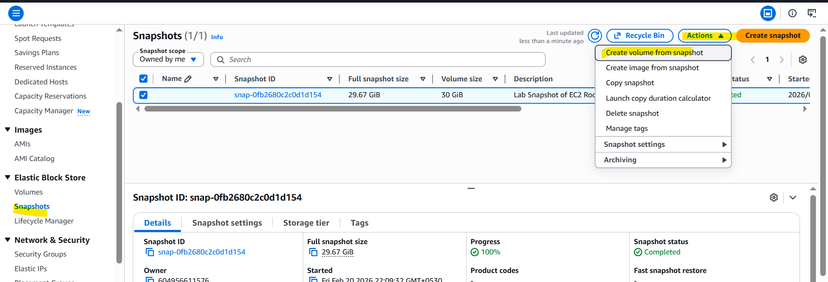
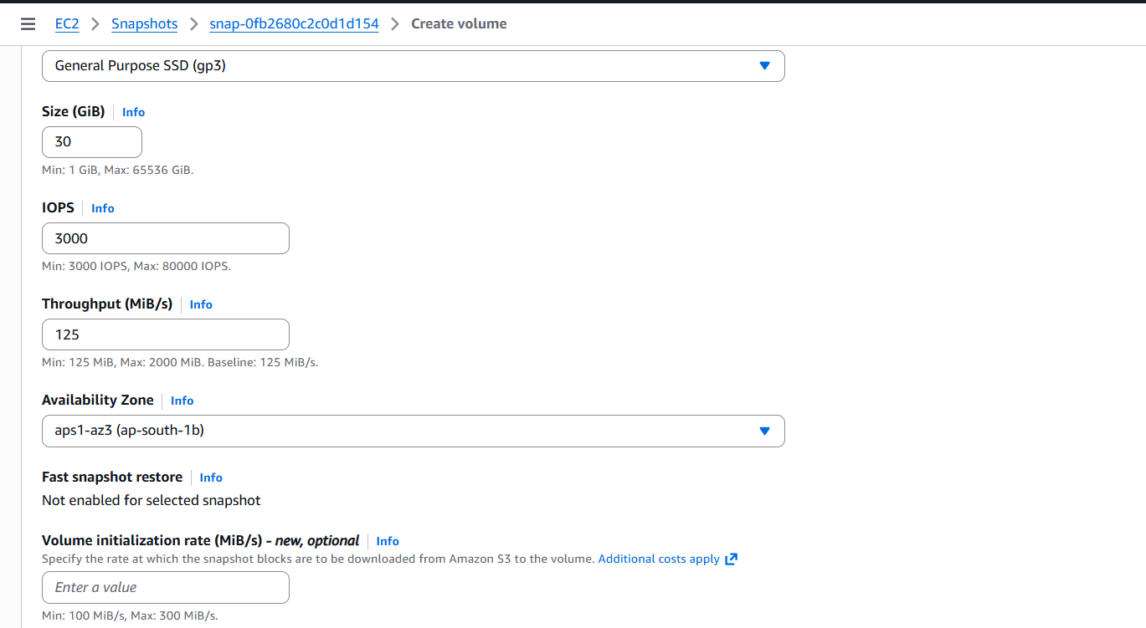

Task 4 >> Create an AMI Using the Snapshot
Step to create AMI by using snapshot >> this is use to have our own AMI (os) while creating a EC2 instance, whatever we have installed in the own AMI, it will be available. while access the VM
Step to create:
Go to snapshot >> click the check box >>> action >> create image from snapshot
